# Results

The overall number of terrestrial mammal species detected was 14, accumulated from a total of 1280 camera trap days across the three sites. Observed false triggers were high, associated with movement of foliage from wind. There were 3 cases of human activity recorded at two of the sites, and excluded from the analysis. While many bird species were captured on camera (141 in total), they were excluded from species analysis as this camera sensitivity is not designed for a robust study on birds.

The fourteen mammal species detected were taxonomically diverse and span across five orders: Primata, Carnivora, Rodentia, Ungulata and Lagomorpha (Table 1). Individual identification was not within the scope of this study. The mammal species most photographed were the Chacma baboon (*Papio ursinus*)*,* steenbok (*Raphicerus campestris*) and cattle (*Bos taurus*)*.* Of the felids, caracals (*Caracal caracal)* and African wild cats (*Felis silvestris cafra*)were both detected on six occasions. There were multiple individuals of greater kudu (*Tragelaphus strepsiceros*), both male and female, of varying ages. Figure 2 demonstrates the changes in water availability for the duration of the study. Images from the study are shown in Figure 3 and 4.

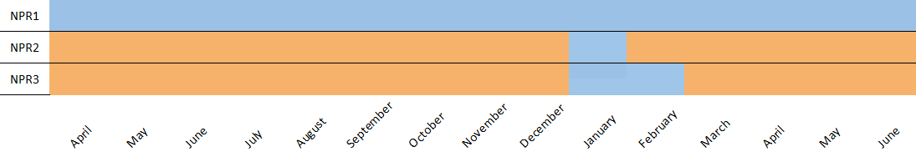

**Figure 2: Presence (blue) or absence (orange) of water at the sites for the duration of the study**

**Table 1: Inventory of photographed species with number of captures and Relative Abundance Indices for all observed mammals during the camera trap survey at the non-perennial Prins River**

|  |  |  |  |  |  |  |
| --- | --- | --- | --- | --- | --- | --- |
|  |  |  | **Site** | | |  |
| **Taxonomic Group** | **Latin name** | **Common name** | **NPR1** | **NPR2** | **NPR3** | **Total** | **RAI** |
| Primata | *Papio ursinus* | Chacma baboon | 76 | 132 | 42 | 250 | 19.3 |
| Carnivora | *Canis mesomelas* | Black-backed jackal | 45 | 13 | 10 | 68 | 5.31 |
|  | *Galerella pulverulenta* | Cape gray mongoose | 0 | 1 | 0 | 1 | 0.08 |
|  | *Felis silvestris cafra* | African wild cat | 1 | 3 | 2 | 6 | 0.47 |
|  | *Caracal caracal* | Caracal | 1 | 3 | 2 | 6 | 0.47 |
|  | *Canis lupus familiaris* | Dog | 0 | 0 | 1 | 1 | 0.08 |
| Rodentia | *Hystrix africaeaustralis* | Cape porcupine | 3 | 0 | 0 | 3 | 0.23 |
| Ungulata | *Tragelaphus strepsiceros* | Greater kudu | 8 | 18 | 17 | 43 | 3.36 |
|  | *Taurotragus oryx* | Eland | 12 | 1 | 4 | 17 | 1.33 |
|  | *Raphicerus campestris* | Steenbok | 3 | 46 | 52 | 101 | 7.89 |
|  | *Oreotragus oreotragus* | Klipspringer | 8 | 1 | 0 | 9 | 0.70 |
|  | *Bos taurus* | Cattle | 27 | 38 | 39 | 104 | 8.13 |
|  | *Oryx gazella* | South African oryx | 0 | 16 | 13 | 29 | 2.27 |
| Lagomorpha | *Lepus saxatilis* | Scrub hare | 0 | 1 | 0 | 1 | 0.08 |
| Aves |  |  | 4 | 11 | 126 | 141 | 11.02 |
| Unidentified |  | Unidentified | 26 | 33 | 25 | 84 | 6.56 |

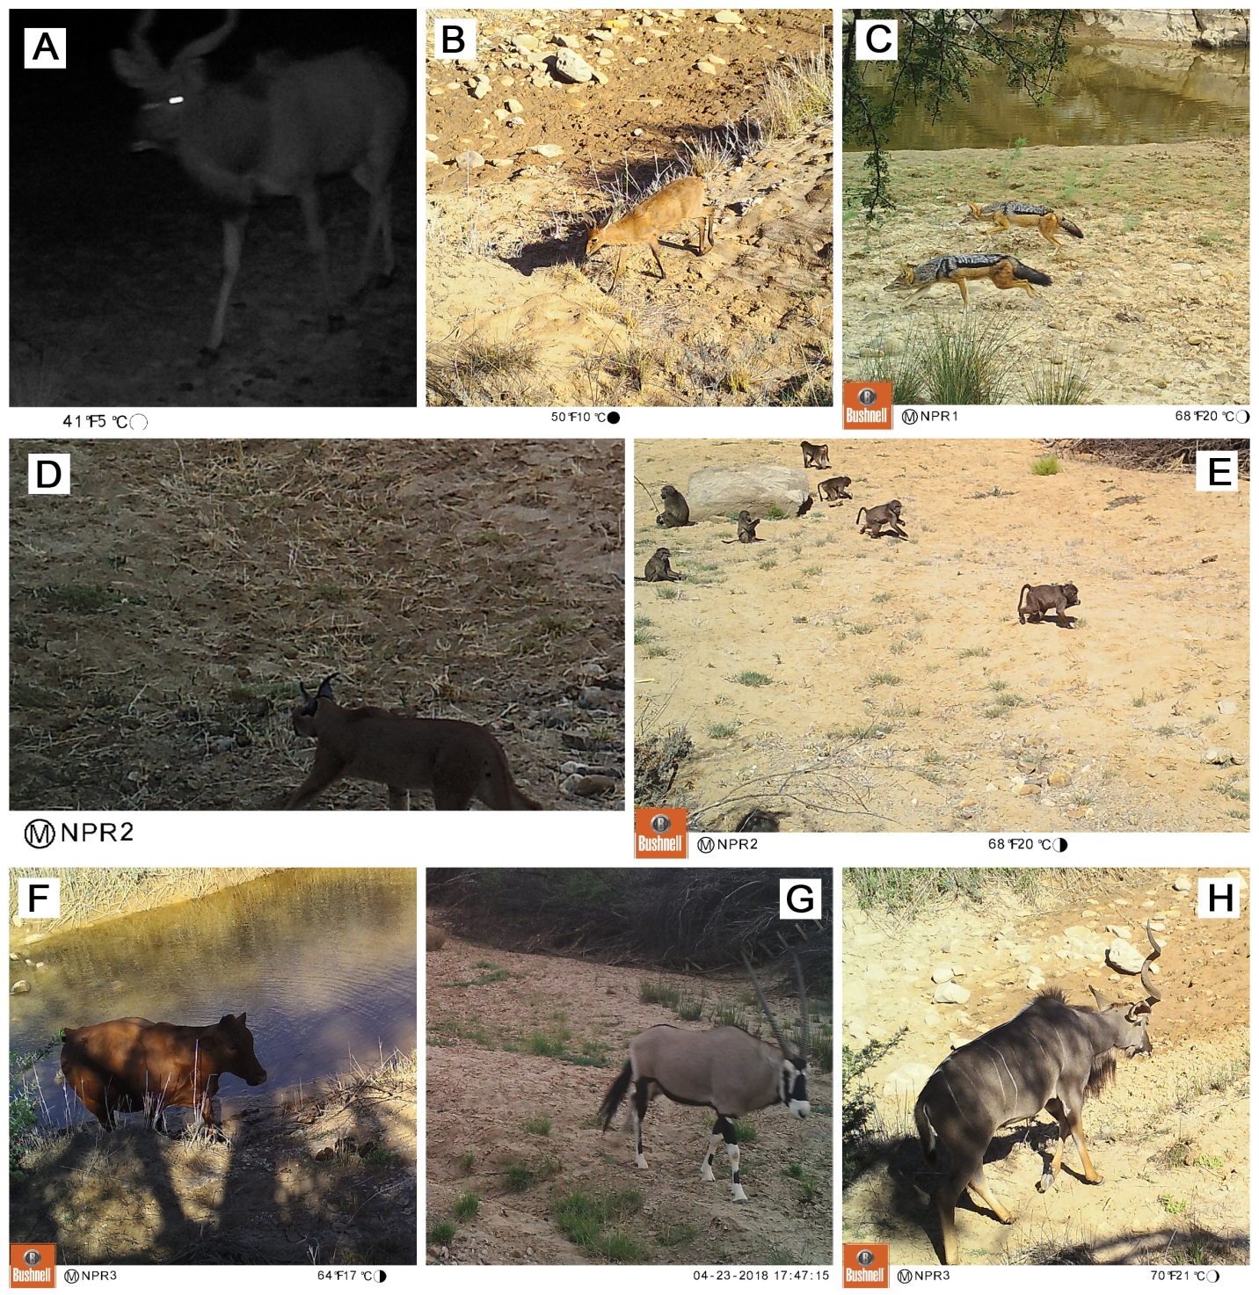

**Figure 3: Camera trapping in the non-perennial Prins River.** (A) Male greater kudu (*Tragelaphus strepsiceros*) during night-time. (B) Steenbok (*Raphicerus campestris*) inside the dry channel. (C) Two black-backed jackals (*Canis mesomelas*). (D) Caracal (*Caracal caracal*) inside the dry channel. (E) A troop of baboons (*Papio ursinus*) inside the dry channel. (F) Cow (*Bos taurus*) inside the water during the flood of January 2018. (G) South African oryx (*Oryx gazella*) (H) A single-horned male greater kudu (*Tragelaphus strepsiceros*).

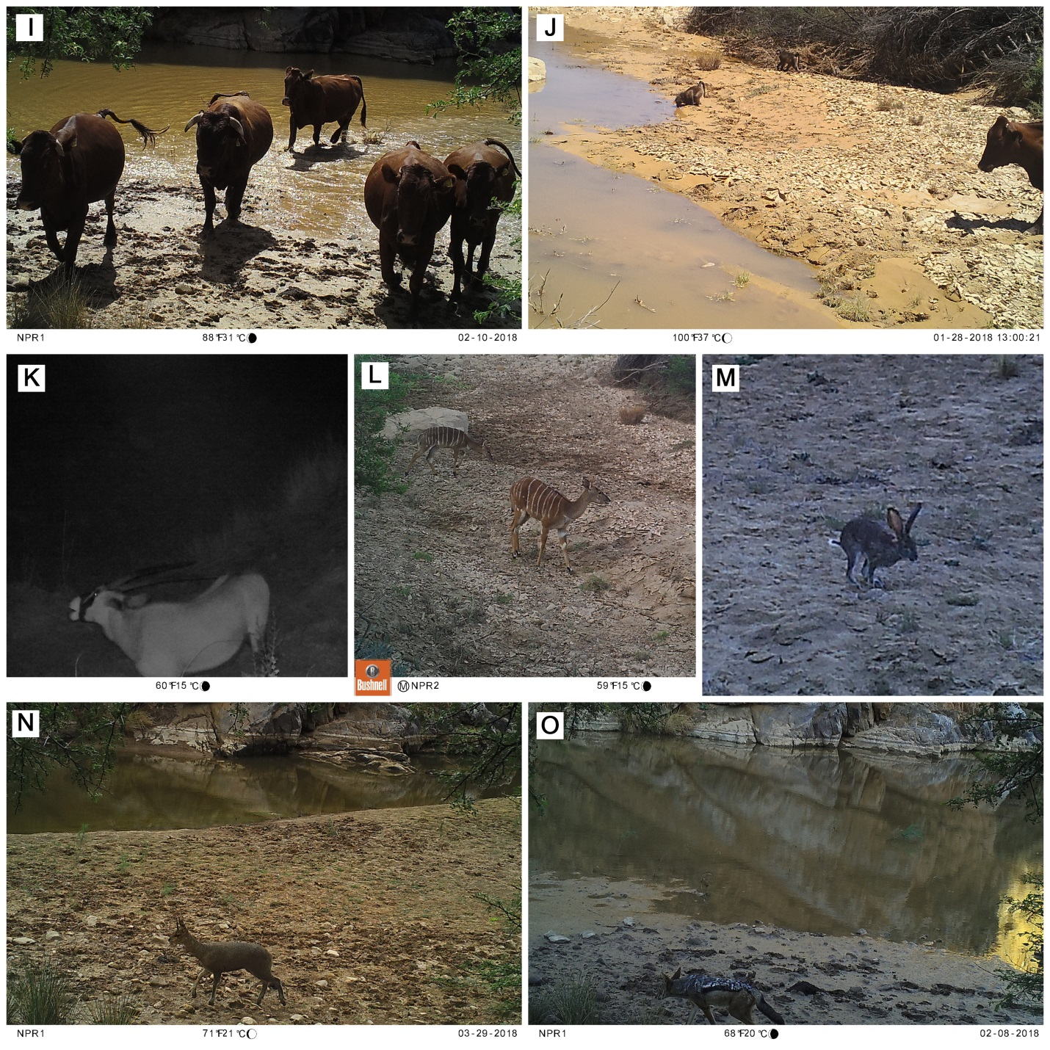

**Figure 4: Camera trapping in the non-perennial Prins River.** (I) Cows (*Bos taurus*) in the flooded pool (J) A cow (*Bos taurus*), and baboon (*Papio ursinus*) drinking from the rapidly drying river (K) South African oryx (*Oryx gazella*) at night. (L) Juvenile greater kudu (*Tragelaphus strepsiceros*). (M) Scrub hare at twilight (*Lepus saxatilis*). (N) Klipspringer (*Oreotragus oreotragus*)(O) Black-backed jackal at the recharged river (*Canis mesomelas*).

To investigate if more animals were detected using motion triggers or timed photographs, the mean number of detections per interval were compared and tested to see if the difference was statistically significant using a two-tailed t-test. The intervals used are shown in Table 2, and represent each time the cameras were checked and batteries replaced. A significant difference was observed (t-testt6 = 3.14; p = 0.02). This demonstrates that detection rate is much higher when photographs are triggered by motion. The difference in detection is greater than a factor of more than twelve (comparing the mean values of 91 against 7.14). The only uncommon individual captured by the hourly photographs was a caracal *(Caracal caracal)*. This suggests that animals that surpass motion detection are more likely to be elusive in nature, such as carnivores.

**Table 2: Summary of total detections and method of trigger for a camera trap survey in the non-perennial Prins River**

|  |  |  |  |  |
| --- | --- | --- | --- | --- |
| Station | Start Date | End Date | Motion | Timed |
| **NPR1** |  |  |  |  |
| Interval 1 | 21/04/2017 | 28/06/2017 | 33 | 4 |
| Interval 2* | 28/06/2017 | 21/11/2017 | 52 | - |
| Interval 3*† | 21/11/2017 | 20/06/2018 | 125 | - |
| **NPR2** |  |  |  |  |
| Interval 1 | 20/04/2017 | 28/06/2017 | 27 | 0 |
| Interval 2 | 28/06/2017 | 21/11/2017 | 70 | 8 |
| Interval 3† | 21/11/2017 | 20/06/2018 | 196 | 16 |
| **NPR3** |  |  |  |  |
| Interval 1 | 20/04/2017 | 28/06/2017 | 21 | 0 |
| Interval 2 | 28/06/2017 | 21/11/2017 | 85 | 1 |
| Interval 3† | 21/11/2017 | 20/06/2018 | 205 | 21 |

*Excluded from t-test analysis as camera only recorded motion-triggered detections

†Heavy rainfall in January 2018 resulted in a flood that recharged the river

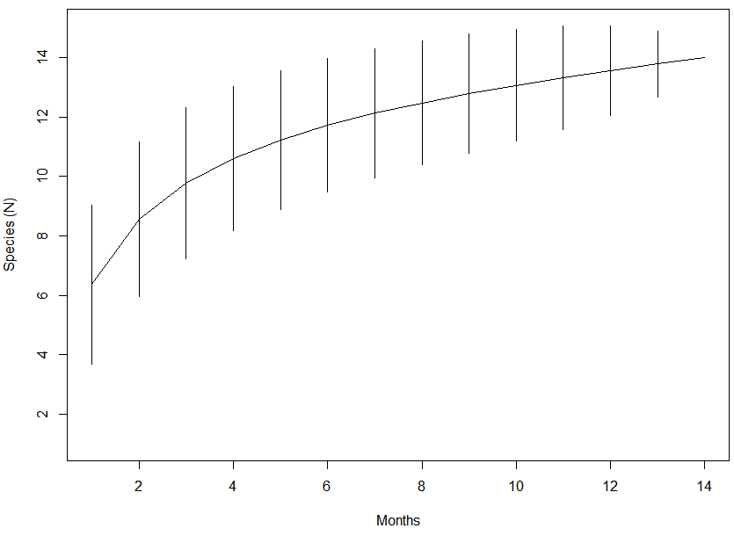

**A**

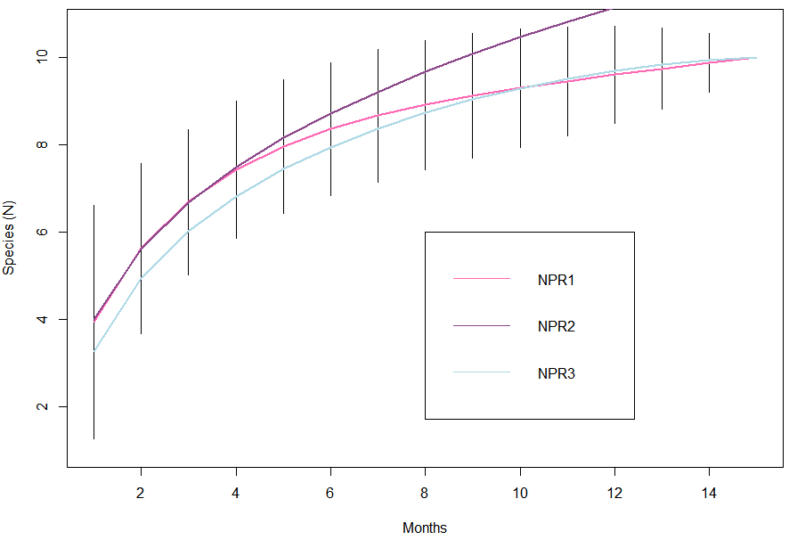

**B**

**Figure 5: Sample-based species accumulation curve describing the terrestrial mammal community richness for the (A) overall study area, and (B) for the three sites. 95% confidence interval displayed as lines.**

The rarefied species accumulation curves (Figure 5b) for two of the three sites (NPR1 and NPR3) are highly similar in the amount of species detected after the eighth month. While these two sites gradually reach an asymptote which suggests the community has been sampled for the full species inventory, NPR2 continues to increase, and suggesting species are still being detected for the first time. Site-specific species richness saw a rapid increase within the five months of study. The overall species accumulation curve (Figure 5a) levels off, suggesting that the environment is close to being sampled entirely, and that it is only through multiple sites that all species were able to be detected. Most likely, any species not detected would be in NPR2 due to the lack of asymptote reached. However this is a model and this suggests that while it is more likely to encounter other species in NPR2, it is not impossible in NPR1 and NPR3. Each site had a minimum of one species that was not detected in the others. The site of highest species richness was NPR2.

A Jaccard similarity index was done in order to quantify similarities in species composition among the environment. There was a high association between the scrub hare (*Lepus saxatilis*) and Cape grey mongoose (*Galerella pulverulenta*). Environments were highly similar, with most species being found in all three sites, with few exceptions. Species that were unique to one site include scrub hare (*Lepus saxatilis*)*,* Cape porcupine (*Hystrix africaeaustralis*), Cape grey mongoose (*Galerella pulverulenta*) and a dog (*Canis lupus familiaris*).

**Figure 6: Average variation in detection frequency of camera traps across all sites for each month of the study duration. Error bars detonate standard error.**

To investigate if seasonality affected detection rates, mean monthly detections across sites were compared (Figure 6) and tested to see if the difference was statistically significant using an ANOVA. A significant difference was found (ANOVA: F11 = 4.86; p < 0001). This shows that detections vary dramatically across the study period. An ad-hoc Tukey HSD was done to determine the source of the difference. There were significant differences found to be between the months April, May, June, July, August, September, October and November against February.

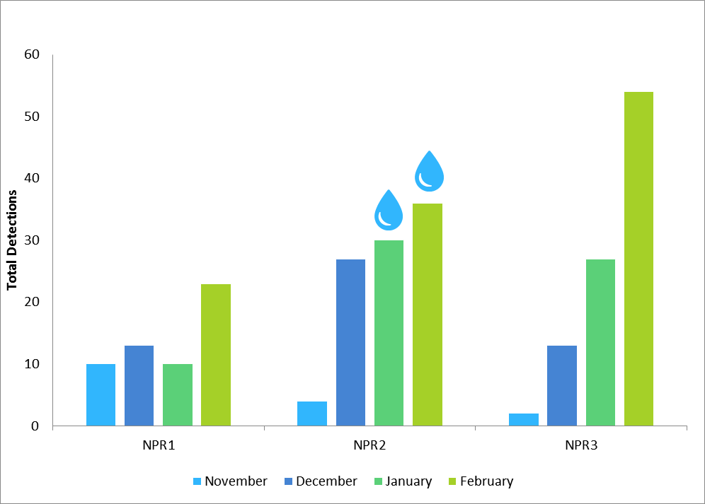

**Figure 7: Total detections for the months preceding and following the flood that occurred in January of interval 3. This flood resulted in the river being recharged. Water droplets represent whether water was present at the pool.**

In an attempt to answer the question if increased water availability increased the visitation rate at the sites, a subset of the total detection data was used for the months November, December, January and February (Figure 7). During late January, a flood occurred which resulted in a flow of water in the pools (Figure 2). To see if this had any effect, an analysis was done consisting of the month in which the flood occurred, and the previous and following months to this. Using a Chi square, sites NPR1 (x2 = 10.67, p = 0.033) and NPR3 (x2 = 31.48, p < 0.001) were found to have a significant variation in visitation rates across these four months. The overall Chi square was found to have a significant variation across all sites (x2 = 19.046, p = 0.004). Detection increases immediately after a recharge event.

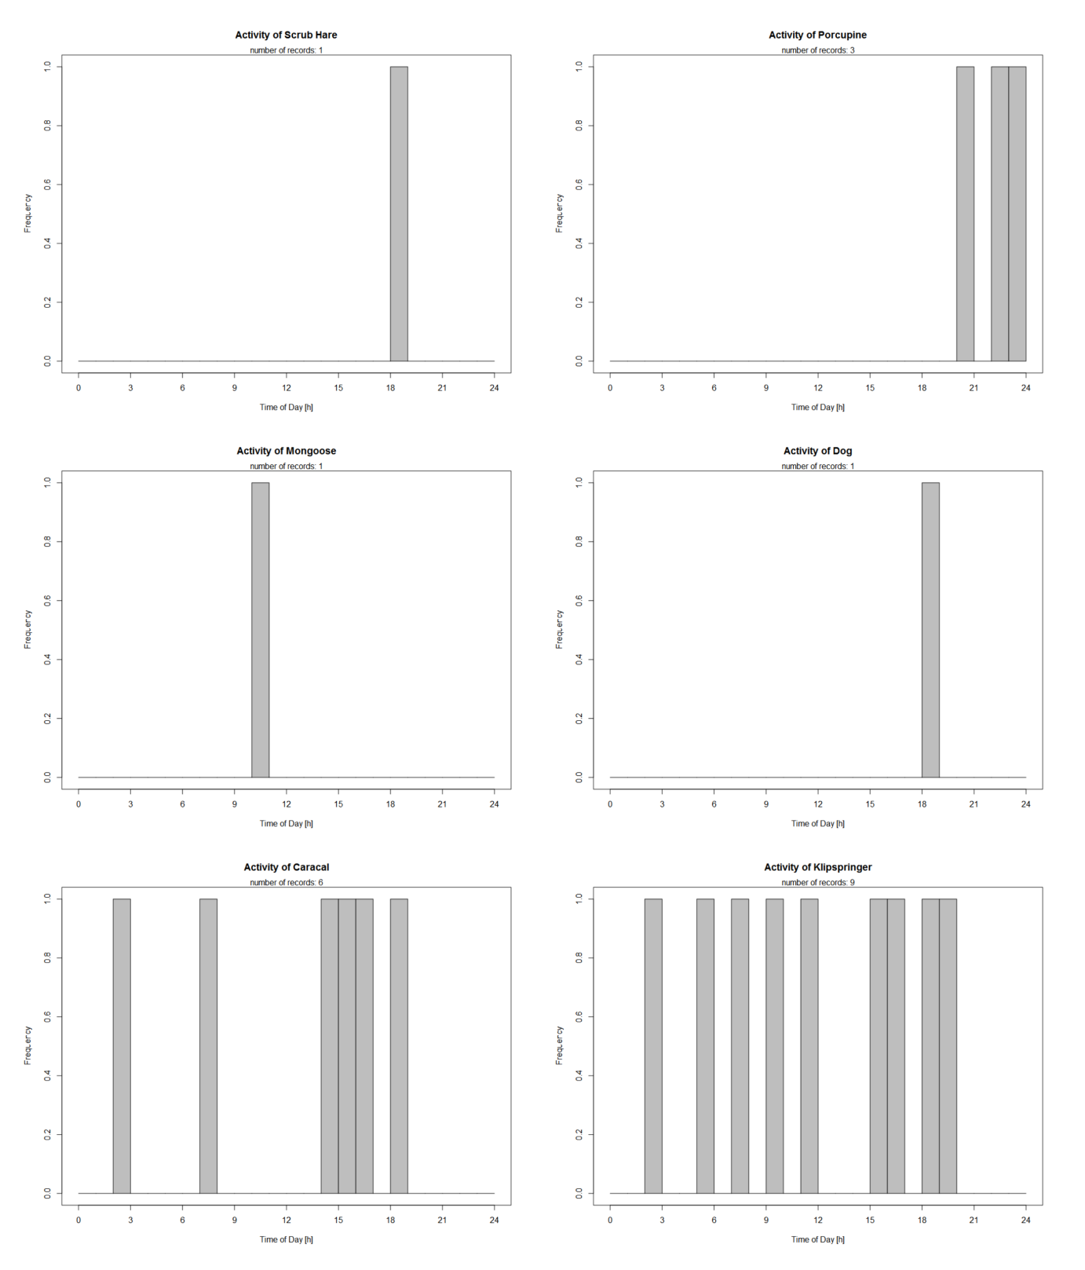

**Figure 8: Histogram displaying the frequency at what time a particular species was detected, accumulated across all sites for species**: scrub hare (*Lepus saxatilis*)*,* Cape porcupine (*Hystrix africaeaustralis*), Cape grey mongoose (*Galerella pulverulenta*), dog (*Canis lupus familiaris*), caracal (*Caracal caracal*) and klipspringer (*Oreotragus oreotragus*).

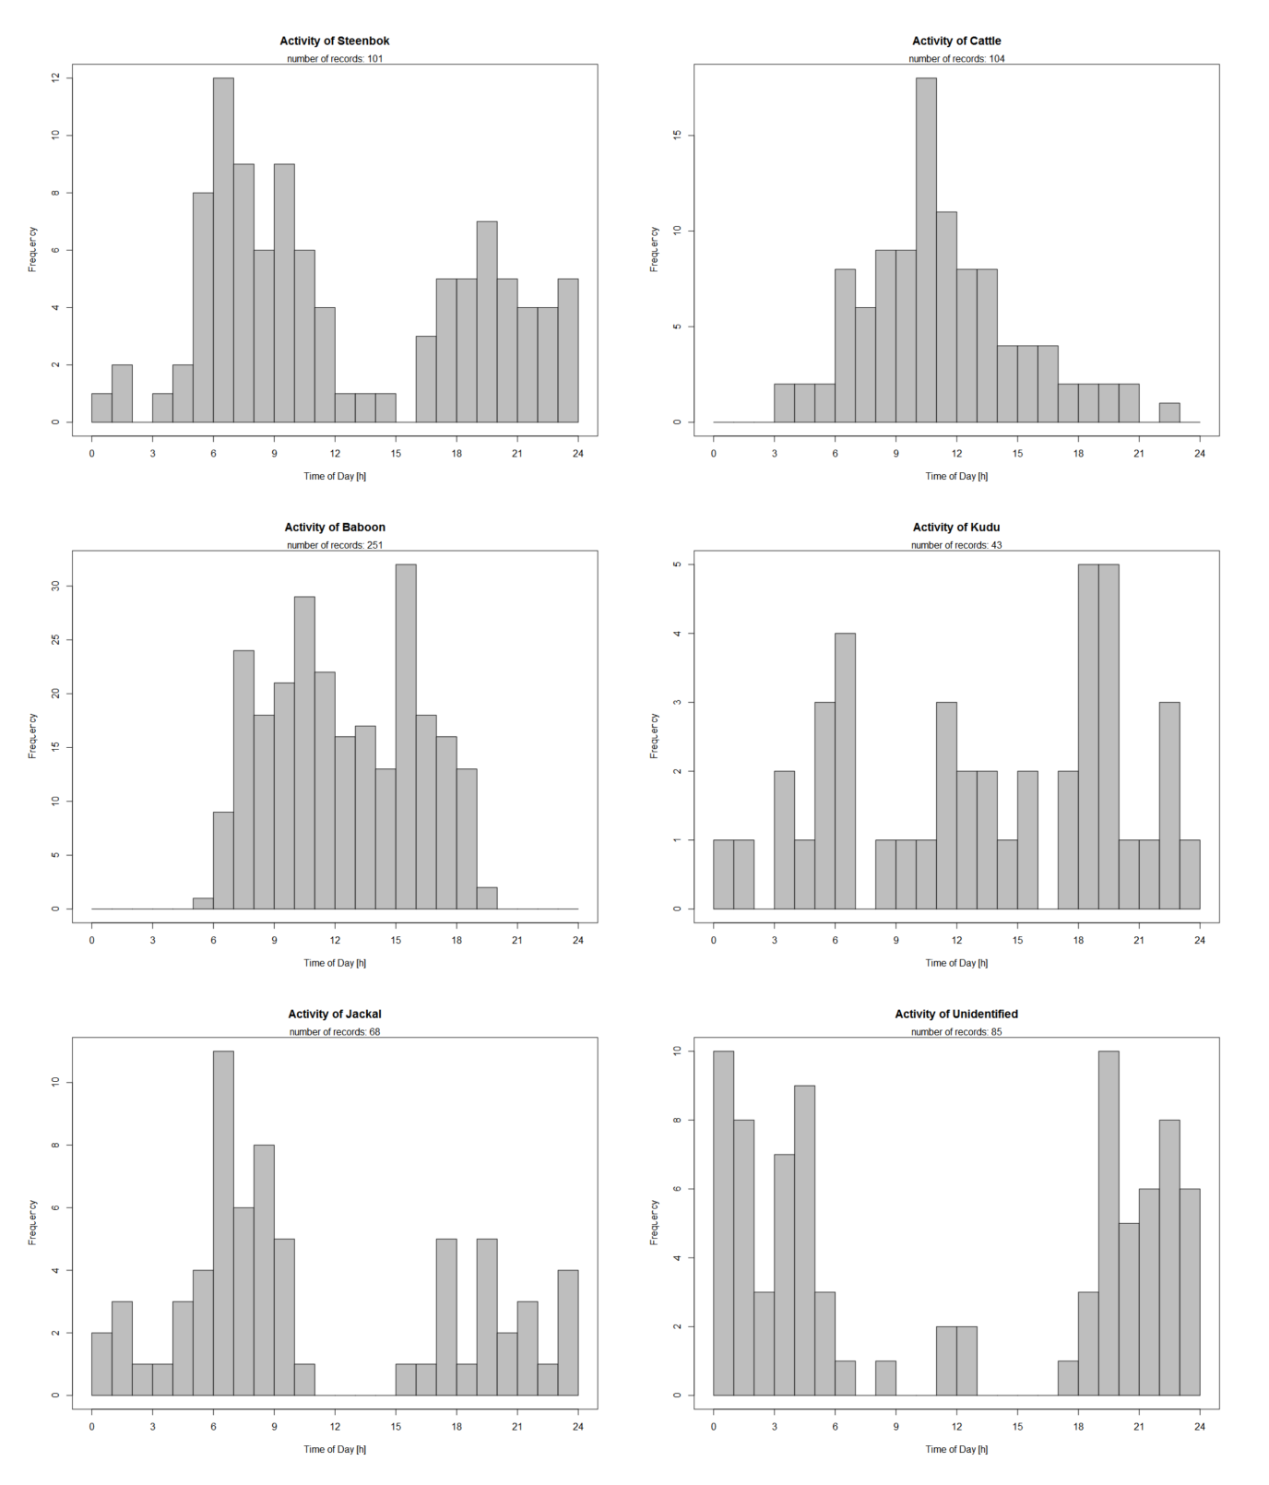

**Figure 9: Histogram displaying the frequency at what time a particular species was detected, accumulated across all sites for species**: steenbok (*Raphicerus campestris*), cattle (*Bos taurus*), baboon (*Papio ursinus*), greater kudu (*Tragelaphus strepsiceros*), black-backed jackal (*Canis mesomelas*) and detections of species that could not be identified.

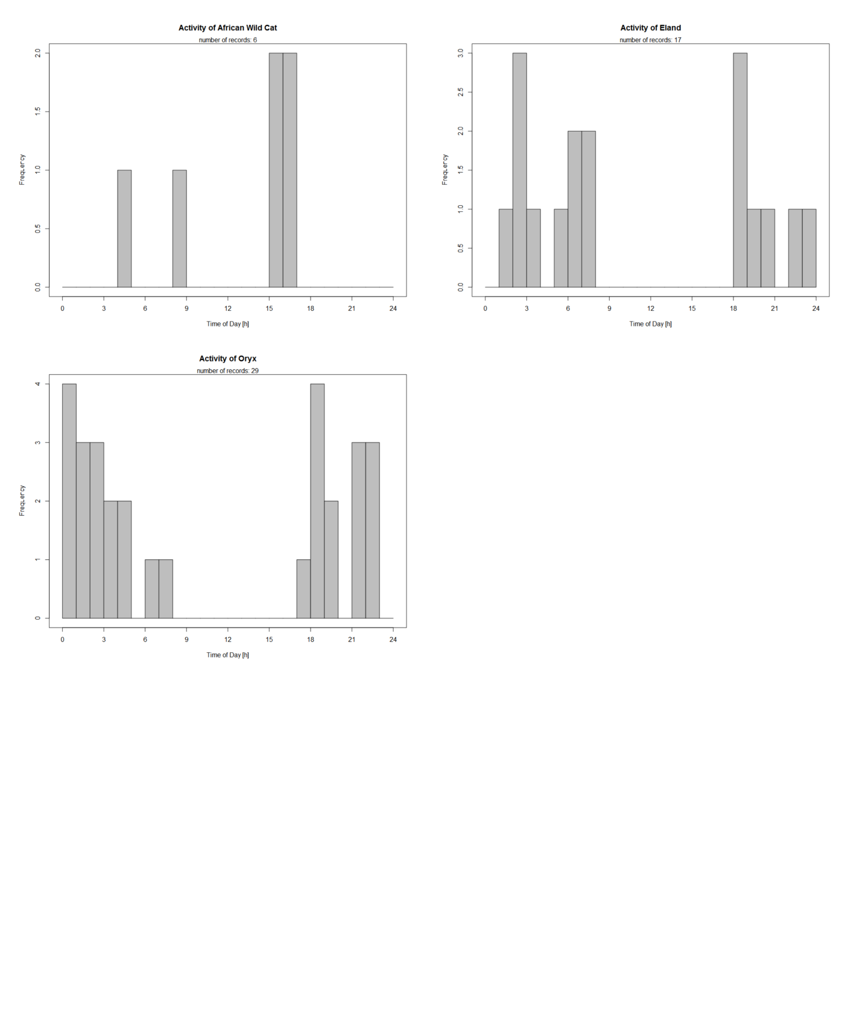

**Figure 10: Histogram displaying the frequency at what time a particular species was detected, accumulated across all sites for species**: African wild cat (*Felis silvestris cafra*), eland (*Taurotragus oryx*) and South African oryx (*Oryx gazelle*).

Detection data was pooled together to examine patterns in frequency that a particular species would visit any of the sites. This is to investigate diurnal variation in mammals at this site. Certain species of Ungulata, such as the eland (*Taurotragus oryx*) and South African oryx (*Oryx gazelle*) occur only after early evening and typically leave before 9:00.

Black-backed jackals (*Canis mesomelas*), predominantly nocturnal, were seen in most of the day besides early afternoon. Although Cape porcupines (*Hystrix africaeaustralis*) had a low occurrence in this study (N = 3), all these detections took place at night. Chacma baboons (*Papio ursinus*) were seen at all hours of the day and never late at night. Most species that could not be identified were detected at night.